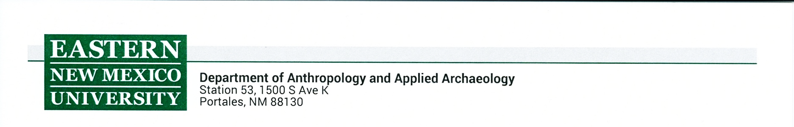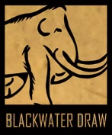

**POLICY AGREEMENT FOR RESEARCH USE OF BLACKWATER DRAW MUSEUM COLLECTIONS**

The Blackwater Draw Museum (BWDM) holds archaeological, ethnological, photographic, and archival collections with particular emphasis on the Southwest and Great Plains regions. The collections are held in public trust and use of the collections is encouraged. BWDM asks that all researchers granted access to the collections adhere to the highest standards of ethical behavior and professionalism. To ensure the preservation and safe handling of collections, all researchers using the collections are asked to read the following rules and sign and date the back of this form.

**CONDITIONS FOR APPROVAL:**

1. Researchers wishing to utilize collections must first fill out a “Collections Research Request” form. This form must be submitted no less than 1 month prior to the desired date of visit. Additional forms that may need to be submitted:
   1. Researchers wishing to photograph any of the collections must first fill out a “Research Photography Request” form.
   2. Researchers wishing to perform destructive analysis must first fill out a “Destructive Analysis Request” form and receive written approval from BWDM staff.
      1. The Museum will not unilaterally approve requests for destructive analysis of any human remains or objects covered by the Native American Graves Protections and Repatriation Act (NAGPRA). The Museum will consult any potentially affiliated tribes wish such requests; these requests will take additional time to review.
2. Student researchers from institutions outside Eastern New Mexico University must include a letter of support with their request from a faculty member at their home institution who is advising their project.
3. Researchers are required to give BWDM a copy of their data and results in a form that the Museum can use.

**PROCEDURES AT THE MUSEUM:**

1. The collections are available for use only from 9:00 AM – 5:00 PM, Monday- Friday. Actual access hours may be more restrictive due to prior staff commitments and other constraints.
2. Once all necessary requests and forms are filled out and approved, researchers must make an appointment to visit collections with a BWDM staff member.
3. Food, drinks (except water in a closed container), smoking, and gum chewing are not permitted in storage areas.
4. Backpacks, purses, coats, etc. are not permitted in collection storage areas. Rings, necklaces, large jewelry, belt buckles, hanging glasses, and other protruding paraphernalia can damage artifacts; remove these items prior to working with the collections.
5. Pencils, notebooks, and others necessary for research are permitted. Pens, markers, and sharp implements are not permitted when working with the collections.
6. Individuals granted access to the collections will not allow others into the room that have not been given permission to be there.
7. Minimal handling of collections is optimal. Handle one object or document at a time, with both hands supporting it. Never handle objects by appendages (e.g. rims, handles, spouts).
8. Follow instructions from the staff member regarding glove requirements depending on the type of materials you are working with.
9. If damage occurs, do not attempt any remedial action. Notify a staff member immediately.
10. Return all objects and materials back to the condition and placement in which you received them. Do not leave objects on tables unless permission has been granted to do so.
11. No objects or documents may leave the collections area unless prior permissions have been granted.

Failure to comply by these rules will result in immediate termination of access and possibly denial of future use of any Blackwater Draw Museum collections.

I, _______________________________ (print name) have read and understand these rules. I understand that failure to comply by these rules will result in the immediate termination of my research and that I may be denied future access to any of the Blackwater Draw Museum’s collections.

_________________________________________ ________________________

Signature Date