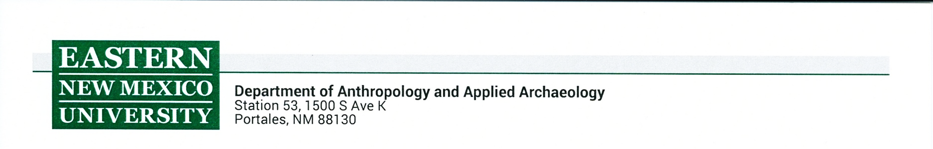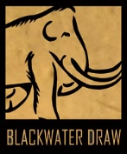

**RESEARCH PHOTOGRAPHY AT THE BLACKWATER DRAW MUSEUM**

The Blackwater Draw Museum distinguishes between research photography and photography for public dissemination. This agreement is for research photography only and also encompasses scanned documents.

1. Research photographs and scanned documents shall only be used for:
   1. Personal research
   2. Presentations to research audiences
   3. Classroom presentations at the college or graduate level
   4. Publication in a thesis or dissertation.
2. All above uses shall require Blackwater Draw Museum be acknowledged.
   1. E.g. “Photo courtesy of the Blackwater Draw Museum”.
3. Any other uses for the archival records will need a separate agreement with the Blackwater Draw Museum.

The researcher’s signature shall constitute agreement with all the conditions stated herein:

______________________________________________ ________________________

Signature Date

______________________________________________

Name (printed)