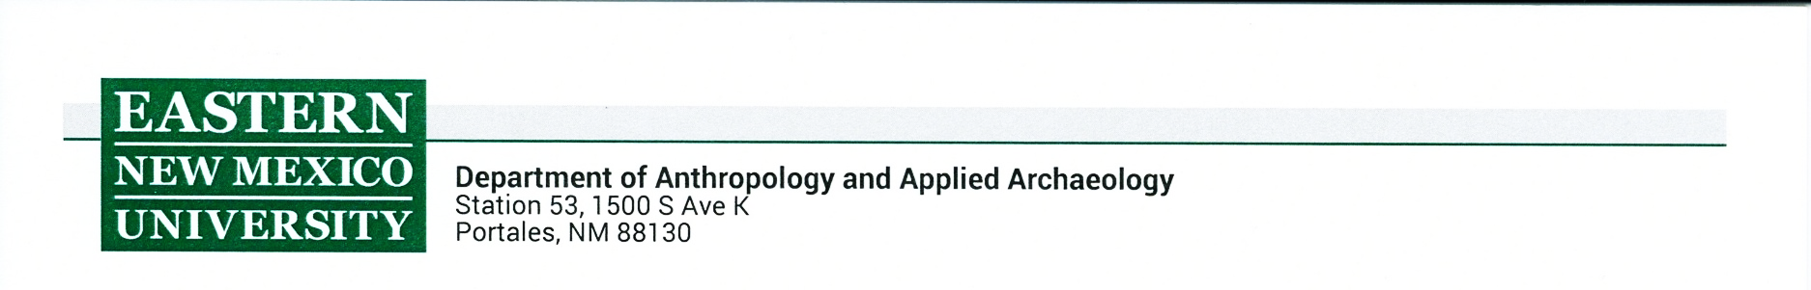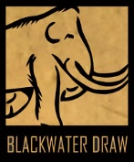

**COLLECTIONS RESEARCH REQUEST**

(Non-Destructive*)

*For requests involving destructive analysis techniques, submit a Destructive Analysis Request form in addition to this form.

**Students**: Please attach a signed letter of support from your supervisor/ advisor with this form.

|  |  |
| --- | --- |
| **Name(s) and Title:** |  |
| **Institutional Affiliation:** |  |
| **Email and Phone:** |  |

|  |
| --- |
| **Requested date(s) to conduct research:** |
| **Collection:** __ Archaeology __ Ethnology __ Archives/ Photos |
| **Purpose of collections research:** |
| **Collection(s) you wish to examine:** |

|  |
| --- |
| **Project description** (feel free to attach a proposal if one exists):  Include information on research question(s), project purpose/ outcomes (including information about potential publication/ dissemination of results), and explanation of the significance of research. |

|  |
| --- |
| Will you need to borrow Museum equipment? If so, what? (scanner, calipers, scale, etc.) |
| Do you wish to take photographs? (separate permission form required): ___ Yes ___ No |

By signing this request form, the researcher is agreeing to:

1. Provide a letter of support from a faculty member (if a student).
2. Obtain permission to take photographs prior to research visit.
3. Record, use, and cite Blackwater Draw Museum catalog numbers in all analyses, data, and publications and give proper credit to the Blackwater Draw Museum in any publications, papers, presentations, theses, or dissertations.
4. Provide the Blackwater Draw Museum a copy of any data, results, photographs, and publications produced from the Collections Research Request.
5. Agree to abide by all terms of the “*Policy and Agreement for Research Use*” form and submit a signed copy to the museum prior to research visit.

__________________________________________________ ___________________

Signature of Requesting Individual Date

**Submit this completed form to the Museum Manager**

**Cenetria Crockett (**[**cenetria.crockett@enmu.edu**](mailto:taylor.j.mccoy@enmu.edu)**)**

FOR COLLECTIONS USE ONLY

Date received: _______________________________ Approved by: ______________________________

Other forms submitted: ____ Photography ___ Destructive Analysis

Notes: _______________________________________________________________________________